## SUMMARY

After selecting a patient from the census, the **Summary** tab is the first tab a user will see. It provides a longitudinal view of a patient’s problems, providers, procedures, and medications across clinical encounters.

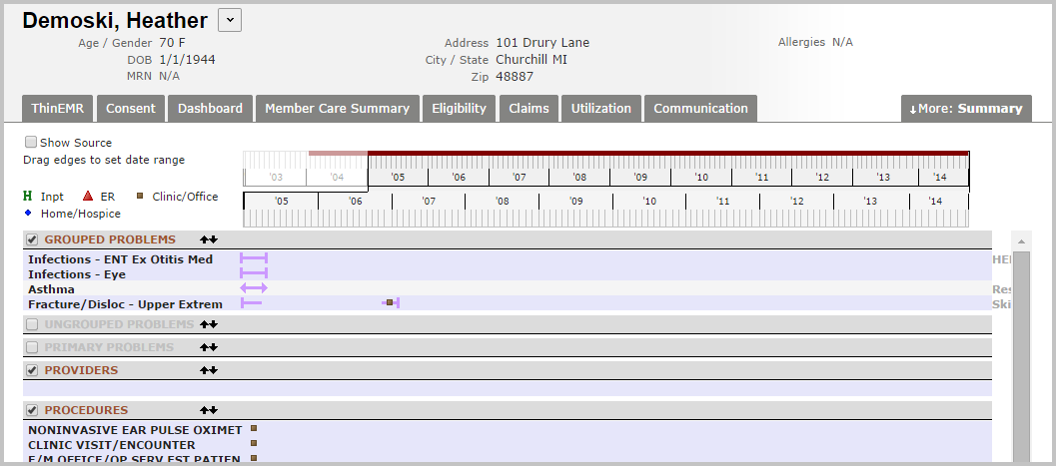

### Timeline

A timeline representing the entire time period for which the patient’s data is available within the HIE is found at the top of the screen below the tabs.

By default, the top row of the timeline begins with the patient’s first available encounter and continues to the present date. However, to improve performance, only the most recent 24 months of data will be displayed in the summary when the page loads. Any history prior to the default time period is represented by the faded portion of the colored line.

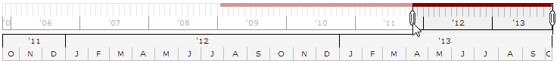

The bottom row of the timeline is an expanded representation of the same time period. Dragging the edges of the date range on the top row increases or decreases the visible date range of the summary.

### Customizing the Summary

Each user may customize the order and content displayed on the Summary tab. Checking/unchecking the box beside each section title will display or suppress that section.

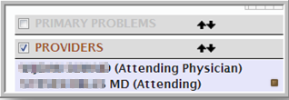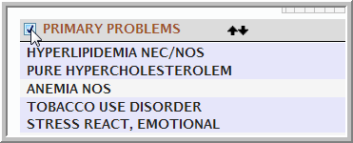

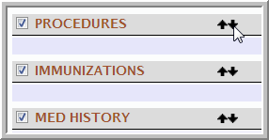Change the order of display by using the up/down arrows beside the section title.

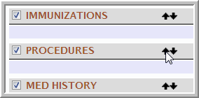

### Detailed Information

Each data point within problems, providers, and procedures is represented on the longitudinal summary by one of the following icons to indicate the type of encounter for each. Medications are represented by a capsule icon.

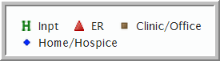 

Position your cursor over an icon to view additional detail for any encounter or medication. A box will appear displaying more detailed information.

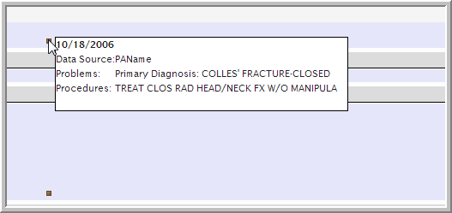

### Problems

Problems are organized by system with the label displayed to the right of the screen.

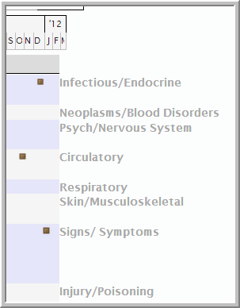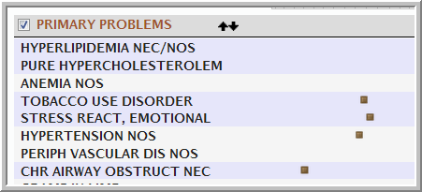

### Medications

Medications are organized by Date, with most recent prescribed at the top. Inpatient and outpatient meds are available.

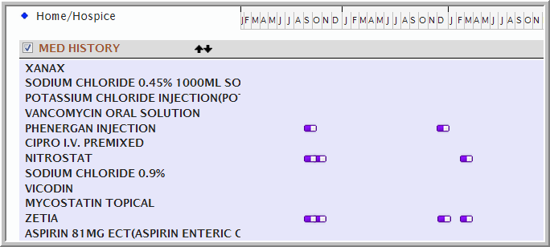

Place your cursor over the meds icon to view detailed information.

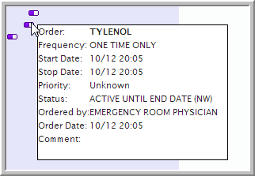

Selecting order by **Class/Name** will group medications in order of drug name and drug class.

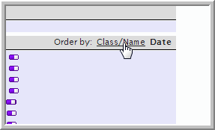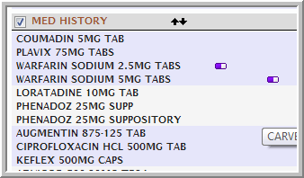

Drug class appears to the right of the grouped medication names.

